

Dr. Mary, Kennedy inc.

2019-04-18

Dr. Kennedy

79345 Little Lights, Mclaughlinbury, FM 40876

Phone: 9711341667

Fax: 6225678701

**Re:** Stephanie, Wiley

**PHN:** 3229491413

**Birthdate:** 25-Oct-1947

**Address:** 343 Cynthia Gardens Suite 543, Lake Melissaview, FL 68242

**Patient number:** 903203323

To Whom It May Concern:

This is a medical letter to state the above patient is pregnant with expected delivery date of 30-Oct-2025. Hoping this information is satisfactory for your requirements.

Thank you.

Sincerely,

Dr. Mary, Kennedy

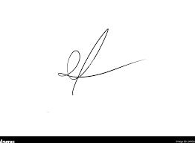

FRCS© NCMP

Clinical Assistant Professor, UBC

Department of Obstetrics and Gynecology SMH